

**Installation Document**

Department of Veterans Affairs,

Pre-Procedure Checklist Tool

VA118-11-RQ-0508

**Intellica Corporation**

**209 W. Poplar**

**San Antonio, Texas 78212**

**01/24/2012**

# Table of Contents

Table of Contents 2

Change Log 3

Introduction 3

Minimum Hardware/Software Requirements 3

Oracle Database Server Installation 4

Web Server Installation 12

# Change Log

|  |  |  |  |
| --- | --- | --- | --- |
| Date | Version # | Author | Revision Description |
| 01/24/2012 | 1 | Craig Rebo | Created |
| 01/30/2012 | 2 | Craig Rebo | Added IIS file permissions to directory |
| 03/30/2012 | 3 | Sael Lugo | Added minimum requirements |
| 07/16/2012 | 4 | Craig Rebo | Updated for Communicator install |
| 12/17/2012 | 5 | Sael Lugo | Removed the “Install Oracle Client” section |
|  |  |  |  |
|  |  |  |  |

# Introduction

This document describes the procedures needed to install the Pre-Procedure checklist tool.

# Minimum Hardware/Software Requirements

The following requirements are the minimum hardware/software requirements to run the VA Pre-Procedure Checklist Tool website.

## Hardware Requirements

### Web Server

* Processor: 3.00 GHz
* RAM: 4 GB
* Hard drive: 0.5 GB free

### Database Server

* Processor: 3.00 GHz
* RAM: 4 GB
* Hard drive: 11.5 GB free

## Software Requirements

### Web Server

* Windows Server 2008 R2 (64-Bit)
* IIS 7.0
* .NET Framework 3.5 SP 1

### Database Server

* Windows Server 2008 R2 (64-Bit)
* Oracle Database Express Edition 11g

# Oracle Database Server Installation

The Pre-procedure checklist tool uses Oracle as the backend database to store Pre-Procedure related data. We are currently using Oracle Database 11g Express Edition for development and prototyping.

1. Login to the Windows database server with administrator privileges
2. Open Internet explorer and navigate to:

<http://www.oracle.com/technetwork/database/express-edition/downloads/index.html>

1. Click the ‘Accept License Agreement’ radio button

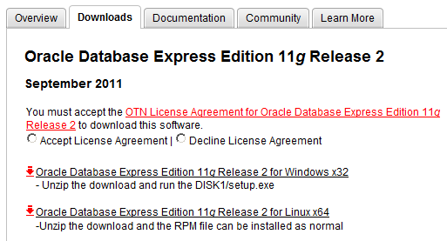

1. Click the ‘[Oracle Database Express Edition 11g Release 2 for Windows x32](http://download.oracle.com/otn/nt/oracle11g/xe/OracleXE112_Win32.zip)’ link and Sign In to Oracle Technology Network (OTN) and download the OracleXE112_Win32 zip file.

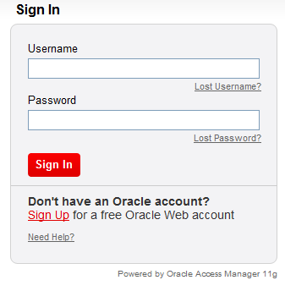

1. **Unzip OracleXE112_Win32 and install Oracle server with default settings.**
2. **Open the windows firewall tool and add inbound and outbound rules for TCP port 1521.**

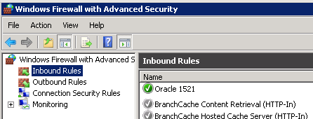

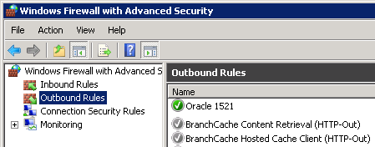

## Oracle Listener Configuration

1. **Open the Net Configuration Assistant**

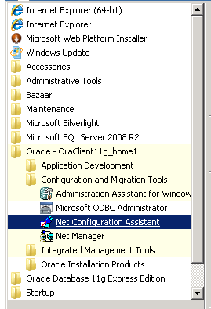

1. **Choose the ‘Listener configuration’ radio button and click next**

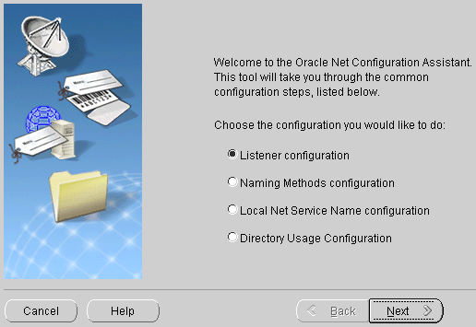

1. **Click the ‘Add’ radio button and check Next**

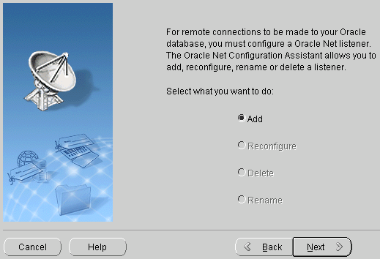

1. **Verify the listener name is LISTENER and click Next**

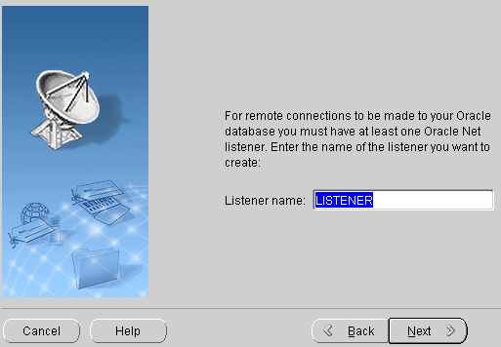

1. **Select the TCP protocol and click Next**

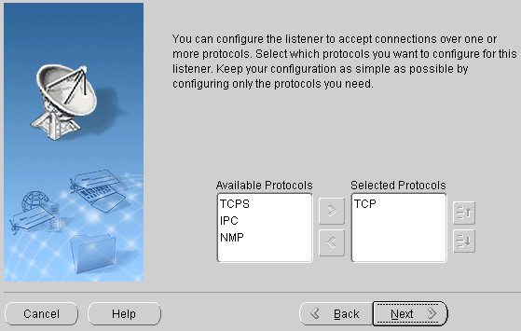

1. **Select the ‘Use the standard port number of 1521’ radio button and click Next. This completes the Oracle listener setup.**

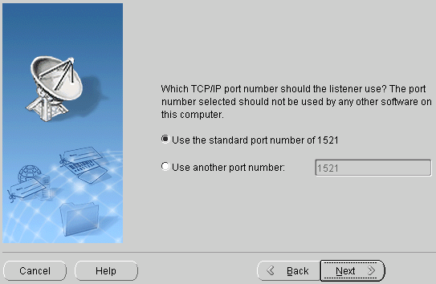

## Create the VAPPCT Table Space and Schema

1. Open the Oracle SQL Command Line

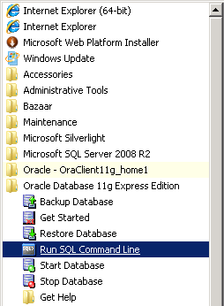

1. Login as the sys user with sysdba privileges using the following command:s

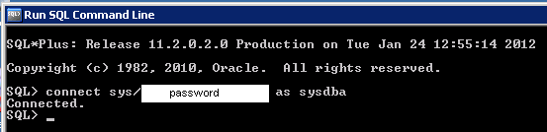

1. The script to create the VAPPCT table space and user is stored in the ‘create_tablespace.sql’ file, the contents of the file are below:

CREATE TABLESPACE VAPPCT

DATAFILE 'C:\oraclexe\oradata\VAPPCT.DBF'

SIZE 200m

AUTOEXTEND ON

NEXT 50M

MAXSIZE UNLIMITED

/

create user VAPPCT identified by "password" quota unlimited on VAPPCT;

grant execute on SYS.DBMS_CRYPTO to VAPPCT;

grant execute on SYS.DBMS_LOB to VAPPCT;

grant execute on SYS.DBMS_LOCK to VAPPCT;

grant execute on SYS.DBMS_SCHEDULER to VAPPCT;

grant execute on SYS.DBMS_SQL to VAPPCT;

grant execute on SYS.UTL_FILE to VAPPCT;

grant execute on SYS.UTL_HTTP to VAPPCT;

grant select on SYS.V_$INSTANCE to VAPPCT;

grant select on SYS.V_$SESSION to VAPPCT;

grant connect to VAPPCT;

grant create table to VAPPCT;

grant create procedure to VAPPCT;

grant create sequence to VAPPCT;

grant create view to VAPPCT;

alter user VAPPCT quota unlimited on system;

To execute the script, run the following command from the prompt:

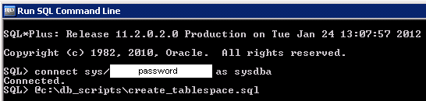

1. This will create the following oracle data file on the database server

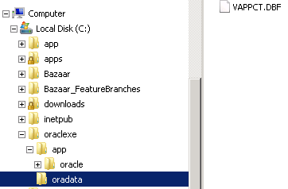

## Import Tables, Procedures and Static Data

1. Login as the sys user with sysdba privileges
2. The script to create the VAPPCT tables, procedures etc… and import static data is stored in the ‘db_export.sql’ file

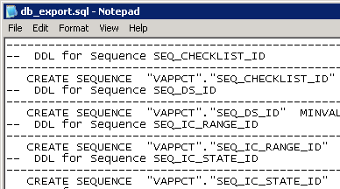

1. Execute the script as follows:

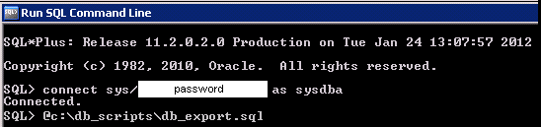

# Web Server Installation

The Pre-procedure checklist is an ASP .Net Web application that resides on a Windows 2008 Server running IIS.

## Modify applicationhost.config

1. Navigate to ‘C:\Windows\System32\inetsrv\config’ and open applicationhost.config file using notepad
2. Modify the following sections as follows, changing the word ‘Deny’ to ‘Allow’:

<section name="handlers" overrideModeDefault="Allow" />

<section name="modules" allowDefinition="MachineToApplication" overrideModeDefault="Allow" />

## ****Verify/Install ASP.NET 3.5****

**The Pre-Procedure checklist tool requires ASP .NET 3.5**

1. **If not already installed, navigate to: ‘http://www.microsoft.com/web/gallery/install.aspx?appid=NetFramework35’ and install using default options.**

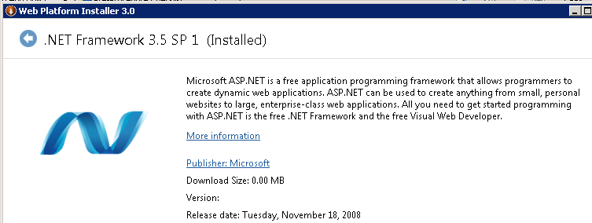

## ****Create and Deploy Web Application****

1. **Create a directory on the Web Server to hold the ASP .NET files used by the Pre-Procedure checklist tool. Copy the source files for the Pre-Procedure Checklist tool to the directory on the web server.**

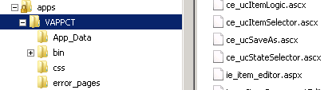

1. **Give IUSR, Network and IIS_USRS access to the folder.**

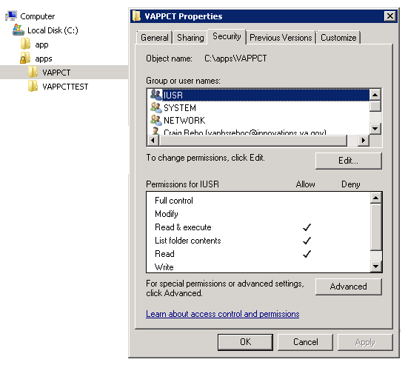

1. **Open IIS manager and create a new application as follows:**

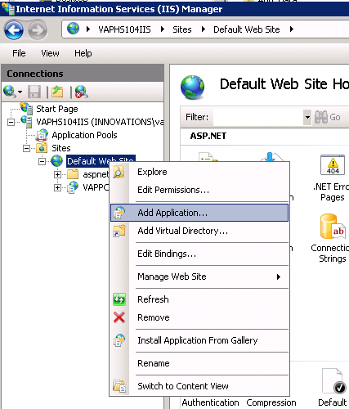

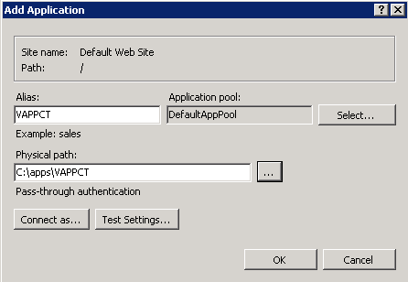

1. **Add vappcthome.aspx to the top of the Default Document list for the application**

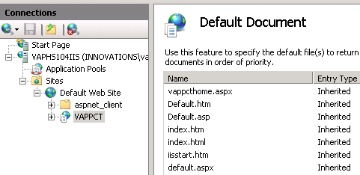

1. **Enable 32-bit application for the application pool as follows:**

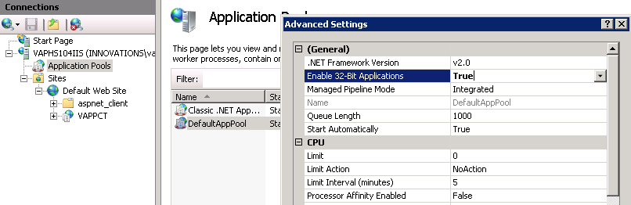

1. **Modify the Web.Config file in the application directory with the connection information used to connect to the database**



**Connection information must be encrypted in the web.config file using the** aspnet_regiis tool **as follows:**

1. Change directory to: windows\microsoft.net\framework\v2.0.50727\
2. Run the following command:

aspnet_regiis –pef “connectionStrings” “e:\websites\vaepi” –prov “RsaProtectedConfigurationProvider”

1. Open the web.config file and make sure the “connectionStrings” section is encrypted.

## ****Create and Deploy VAPPCT Communicator****

The Communicator is a Windows service that queries MDWS for patient results and updates the VAPPCT database. This service is installed on the Web Server and updates results every 5 minutes.

1. **Open the VAPPCTComm project and build the solution in release mode.**

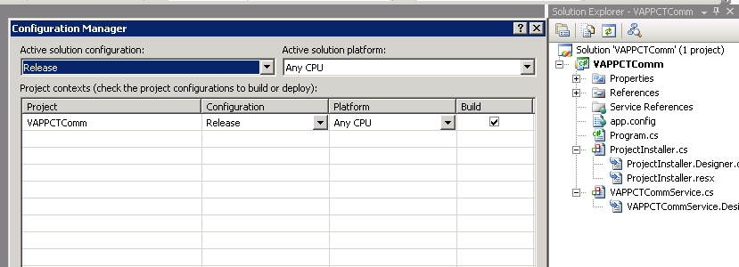

1. **This will create the fooling files in the bin/release directory.**

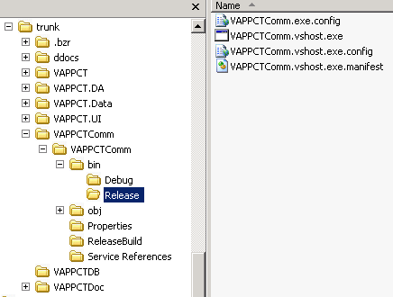

1. **Copy the files to the ReleaseBuild folder under the VAPPCTComm folder. This folder contains batch files that will be used to encrypt setting s in the config file and install the service.**

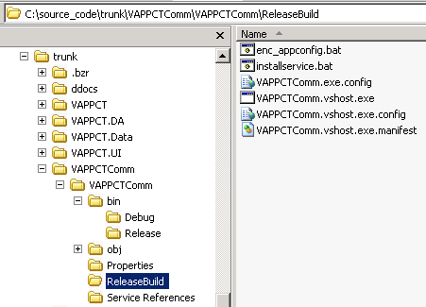

1. **Transfer the files to the webserver and open the VAPPCTComm.exe.config file with notepad and edit the settings for the production environment and save the file.**

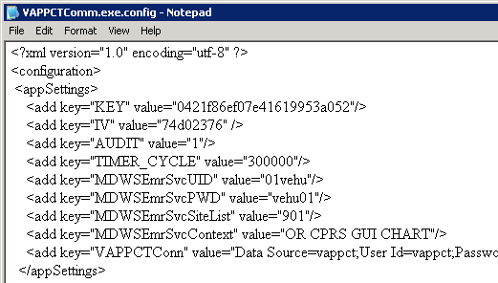

1. **Edit the enc_appconfig.bat file changing the paths as needed. This batch file is used to encrypt the settings in the config file.**

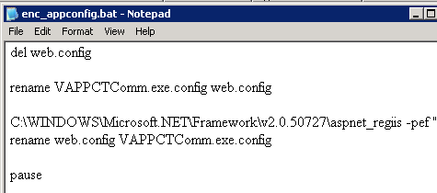

1. **Run the enc_appconfig.bat file as administrator to encrypt the config file. Open the file with notepad and make sure the settings are encrypted.**

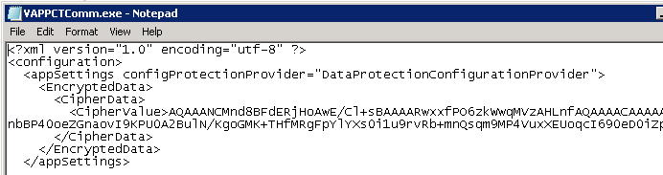

1. Open installservice.bat with notepad and edit the settings for the production environment.

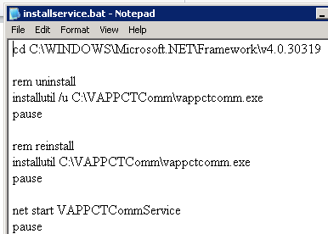

1. Run installservice,bat as administrator to install the service and then open the services manager and verify the service is installed and running.

